Q 1 wap to print number 1 to 100.

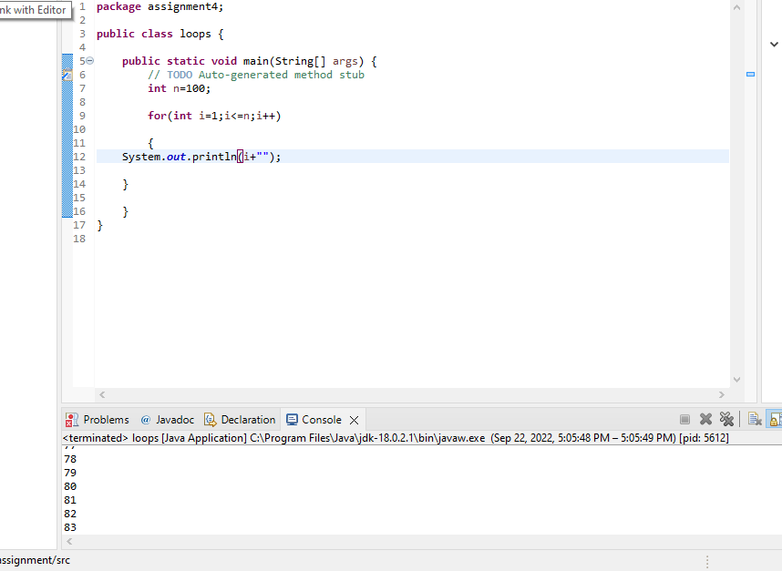

Q 2 wap to print even numbers between 1 to 20

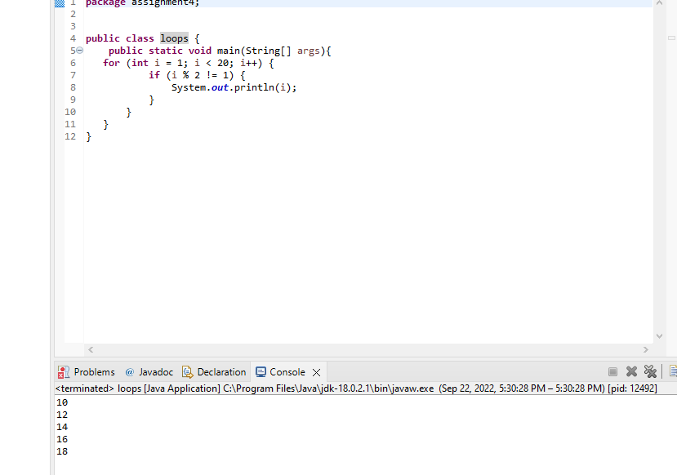

Q 3 wap to print cube of 1 to 5 number.

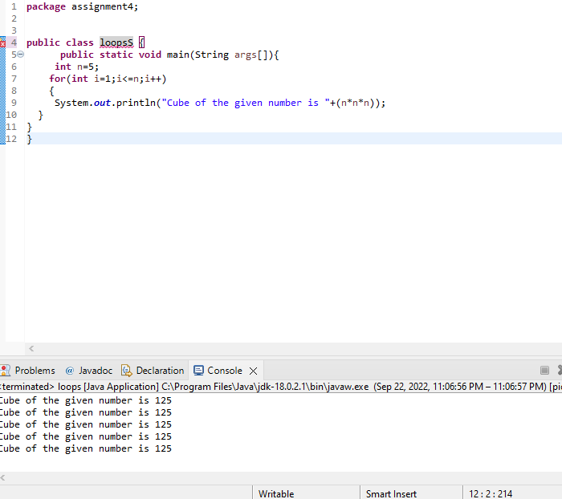

Q 4 wap to check if a number is prime or not .

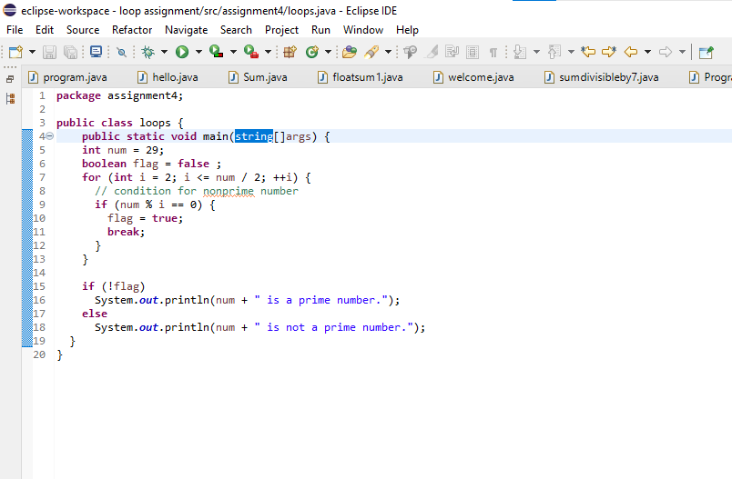

Q 5 wap to print fibonacci series using for loop i.e adding last two results  
ex  0 1 1 2 3 5 8 13 21 34

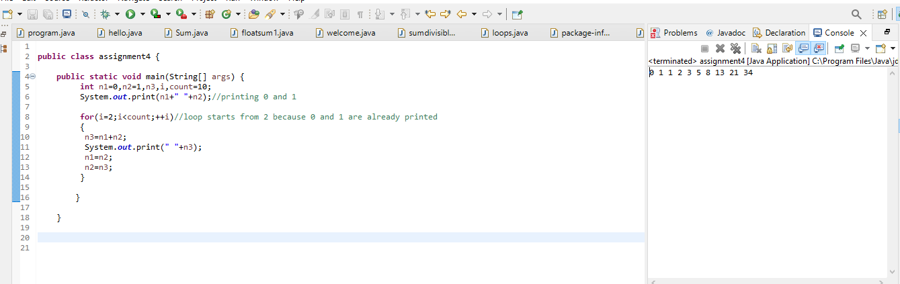

Q 6 wap to print factorial of a number  
   5\*4\*3\*2\*1

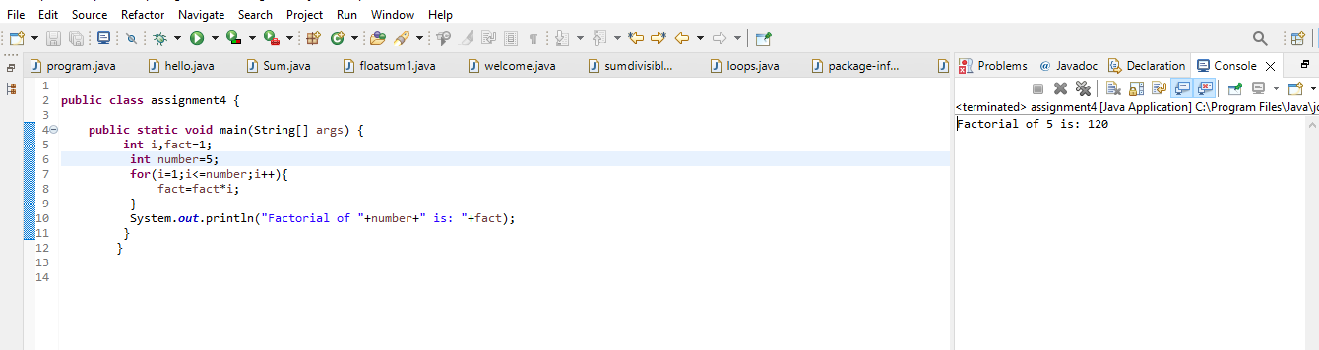

Q 7wap to ask a number from user and print table of that number

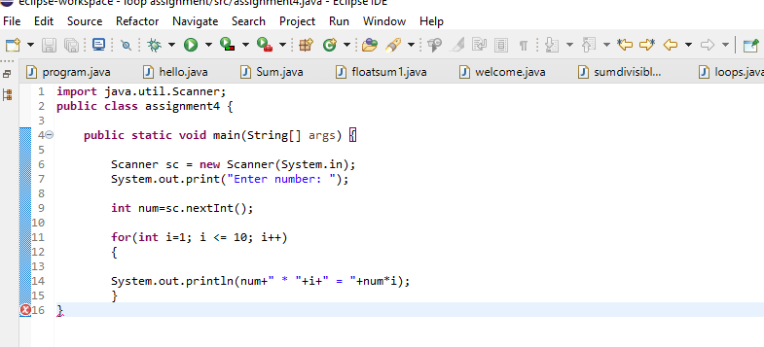

Q 8 wap to print prime numbers between 2 to 20

